ACTIVITY-5
NAME- G. Gopi Chand
REG NO- 192424384
COURSE CODE-DSA 0603
COURSE NAME- DATA HANDLING AND VISUALISATIONS

Activity 1: Geospatial Data Visualization
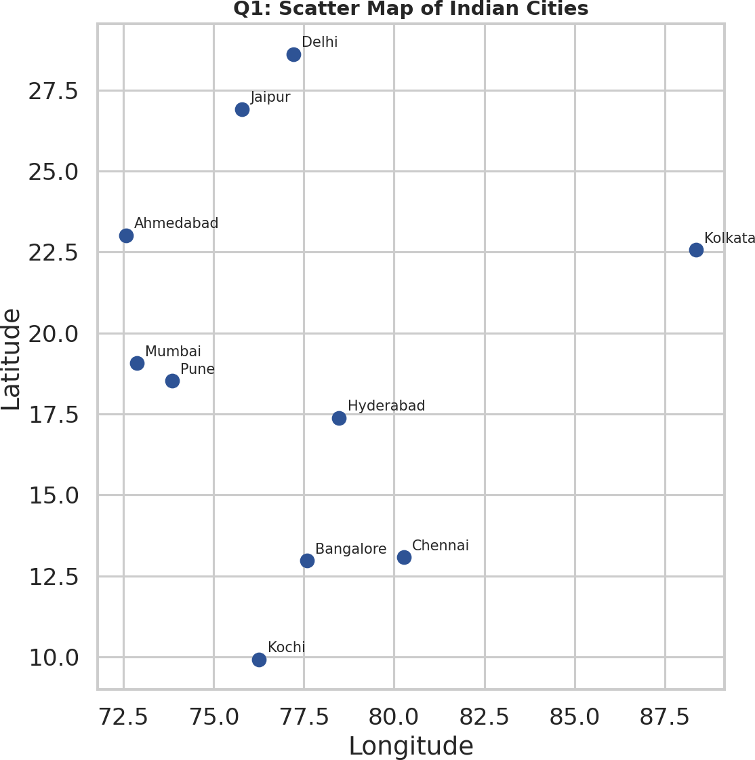

Figure 1.1 (Q1) - Scatter map of Indian cities by longitude/latitude.

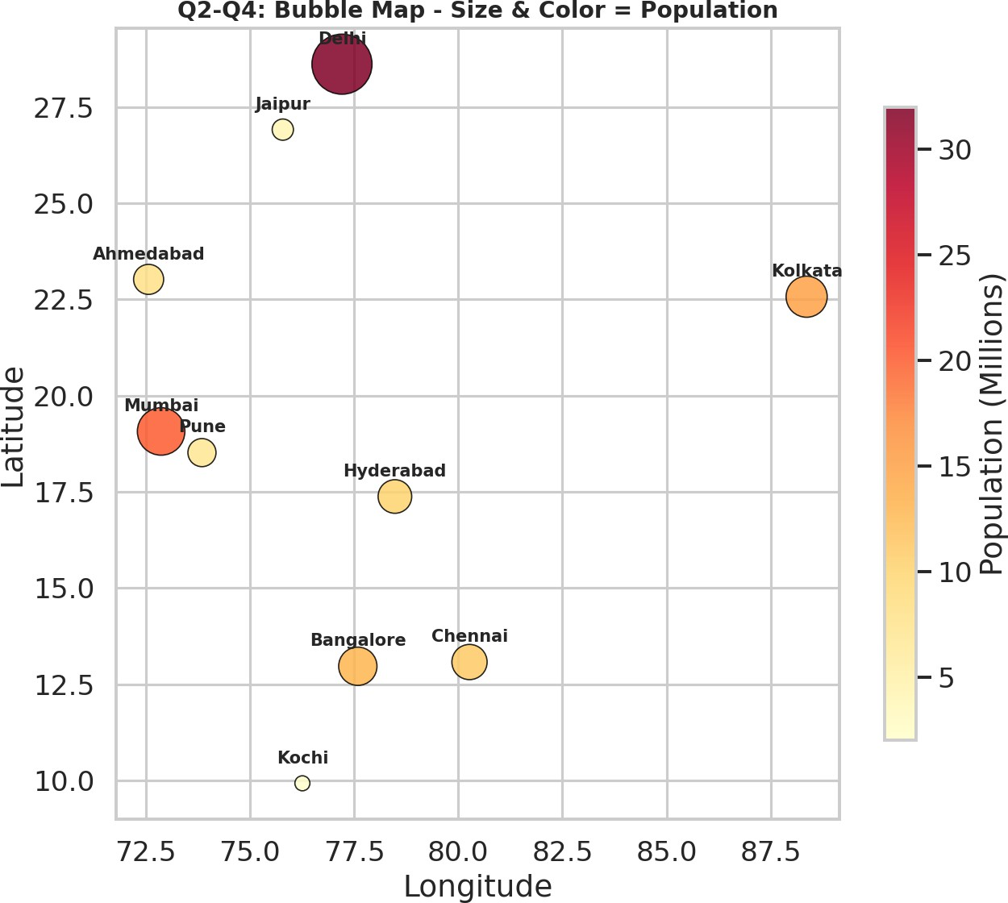
Figure 1.2 (Q2-Q4) - Bubble map: size & color = population, labeled with geom_text().

Q1. Create a scatter map showing all cities.
See Figure 1.1 - each point is one city plotted at its (Longitude, Latitude).
Q2. Bubble map where bubble size represents population.

See Figure 1.2 - bubble radius scales with population (geom_point(size = Population)).
Q3. Label each city using geom_text().
City names are overlaid above each bubble in Figure 1.2 via geom_text(aes(label = City)).
Q4. Different colors based on population size.
Bubble fill color follows a yellow-to-red gradient scaled to population (scale_color_gradient()) in Figure 1.2.
Q5. City with the highest population.
Delhi, with 32 million people - visibly the largest, darkest-red bubble in Figure 1.2, well ahead of Mumbai (20M) and Kolkata (15M).

Activity 2: Network Visualization
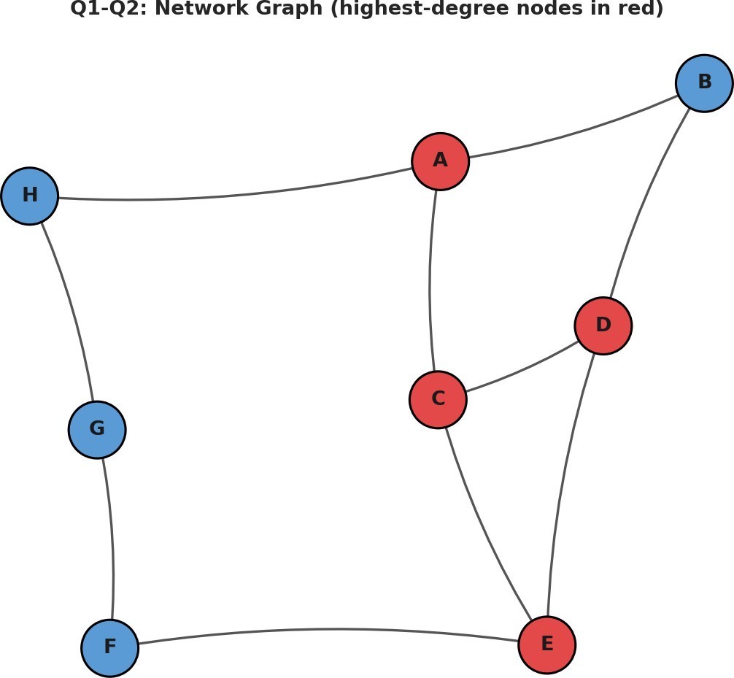

Figure 2.1 (Q1-Q2) - Directed network graph; highest-degree nodes highlighted in red.

Q1. Create a network graph using igraph.
See Figure 2.1 - built with graph_from_data_frame() and plot.igraph().
Q2. Node labels and custom colors.
Node names are shown via vertex.label, and nodes are colored with vertex.color (red = highest degree, blue
= others) in Figure 2.1.
Q3. Degree of each node.
Using degree(g, mode='total') (in-degree + out-degree): A=3, B=2, C=3, D=3, E=3, F=2, G=2, H=2.
(In-degree: A=1,B=1,C=1,D=2,E=2,F=1,G=1,H=1 | Out-degree: A=2,B=1,C=2,D=1,E=1,F=1,G=1,H=1.)
Q4. Node with the highest number of connections.
Four nodes are tied for the highest total degree of 3: A, C, D, and E - each is the endpoint of 3 edges combined (incoming + outgoing). This is visible in Figure 2.1 as the four red-highlighted nodes, which sit at the busiest junctions of the cycle-like graph structure.
Q5. Plot the network using a circular layout. See below - built with layout_in_circle(g).

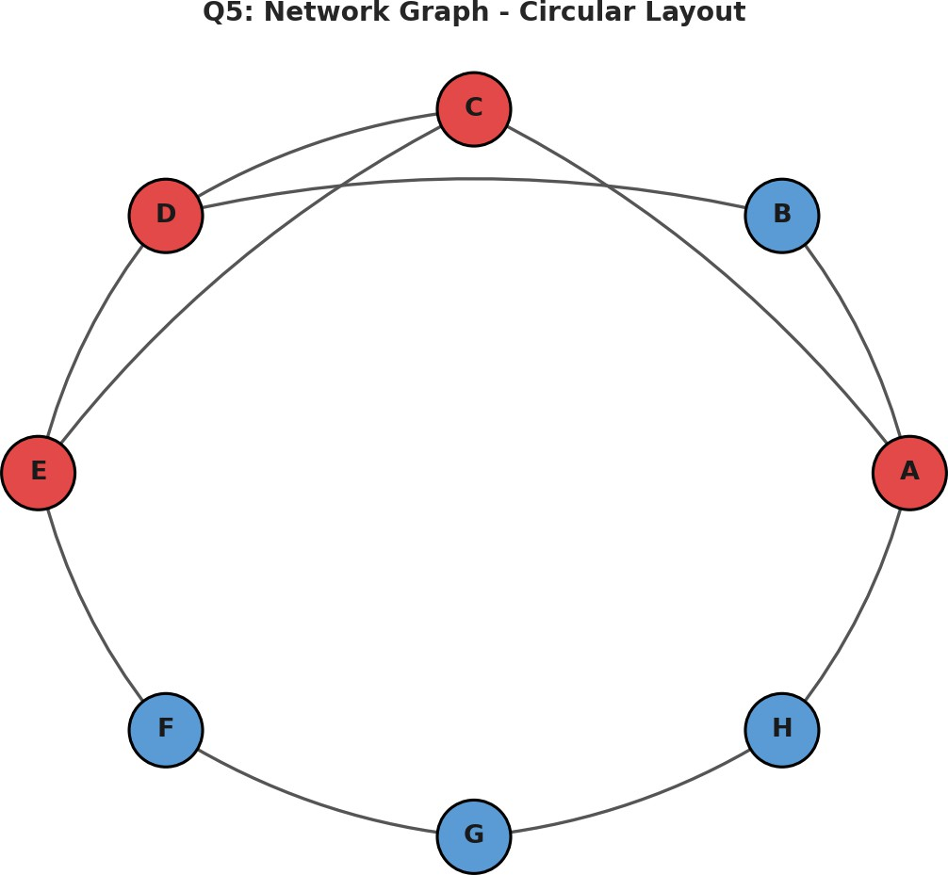

Figure 2.2 (Q5) - Same network drawn with a circular layout.

Activity 3: Temporal Data Representation
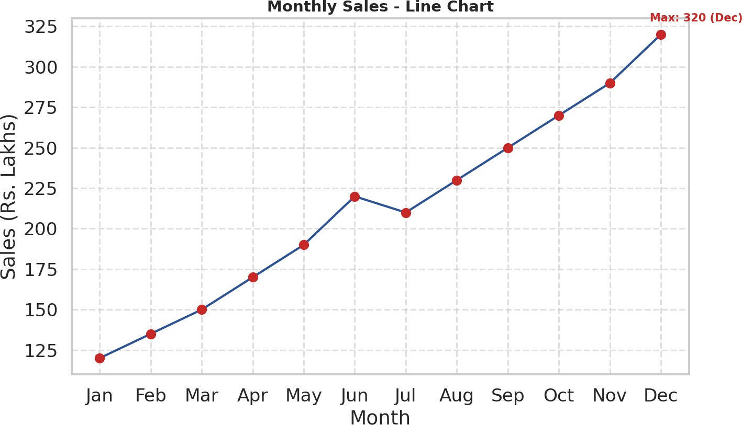

Figure 3.1 - Monthly sales line chart with grid lines, month labels, and highlighted points.

Q1. Line chart of monthly sales.
See Figure 3.1 - built with plot(type='n') + lines() to draw the connecting trend line.
Q2. Custom month names via axis().
The x-axis uses axis(1, at = 1:12, labels = months) to show Jan-Dec instead of the numbers 1-12.
Q3. Highlight data points using pch=19.
Each month's value is marked with a solid filled circle (points(..., pch = 19)), shown in red in Figure 3.1.
Q4. Grid lines and proper axis labels.
Dashed grid lines are added with grid(), and both axes are labeled ("Month", "Sales (Rs. Lakhs)").
Q5. Month with maximum sales.
December, with Rs. 320 Lakhs - the peak of the whole year and the final point on the rising trend line in Figure 3.1, more than 2.6x January's Rs. 120 Lakhs.

Activity 4: Multivariate Data Visualization
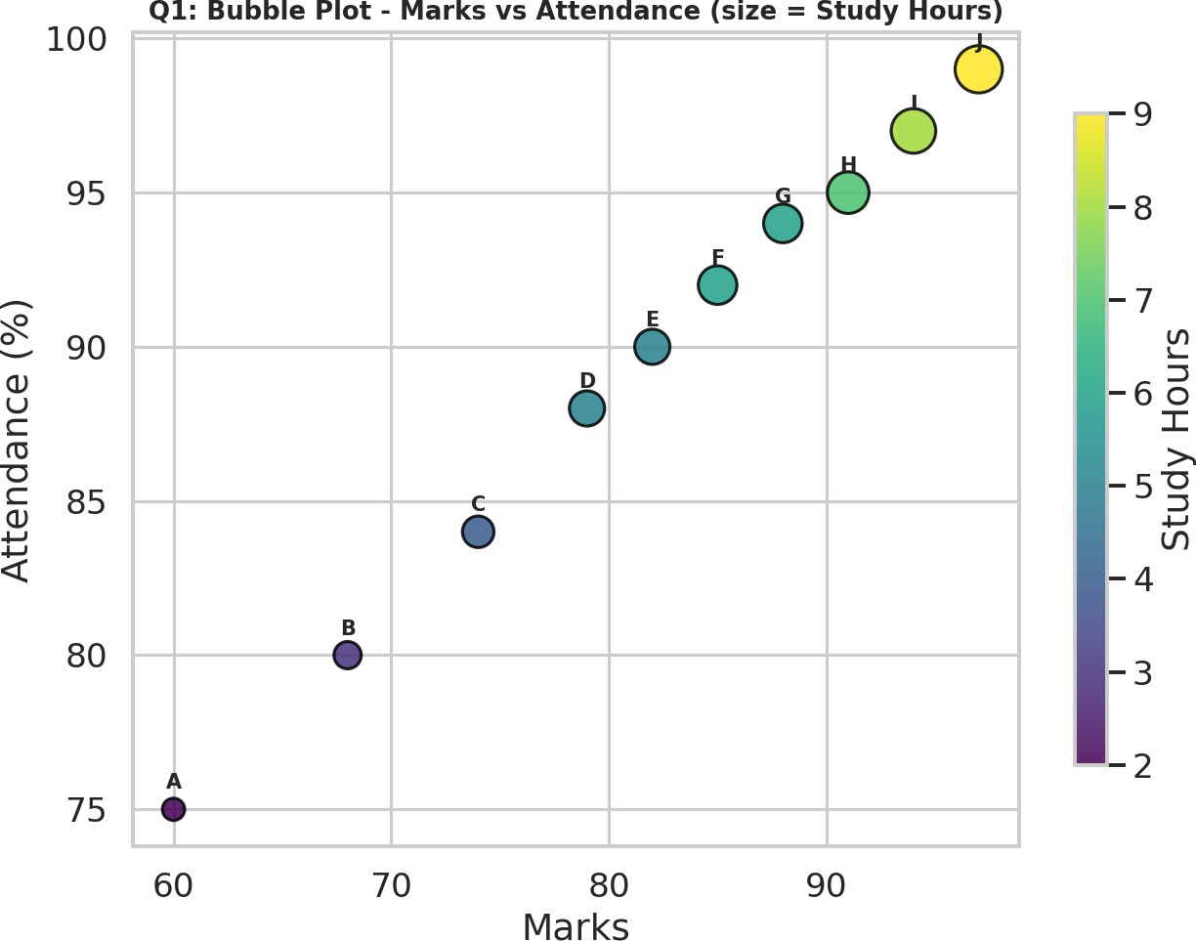

Figure 4.1 (Q1) - Bubble plot: Marks vs Attendance, bubble size = Study Hours.

Q1. Bubble plot - Marks (x), Attendance (y), size = Study Hours.
See Figure 4.1 - built with geom_point(aes(size = StudyHours, color = StudyHours)).
Q2. Scatter plot matrix using pairs().
See Figure 4.2 below - every pairwise combination of Marks, Attendance, Study Hours, and Projects is plotted.
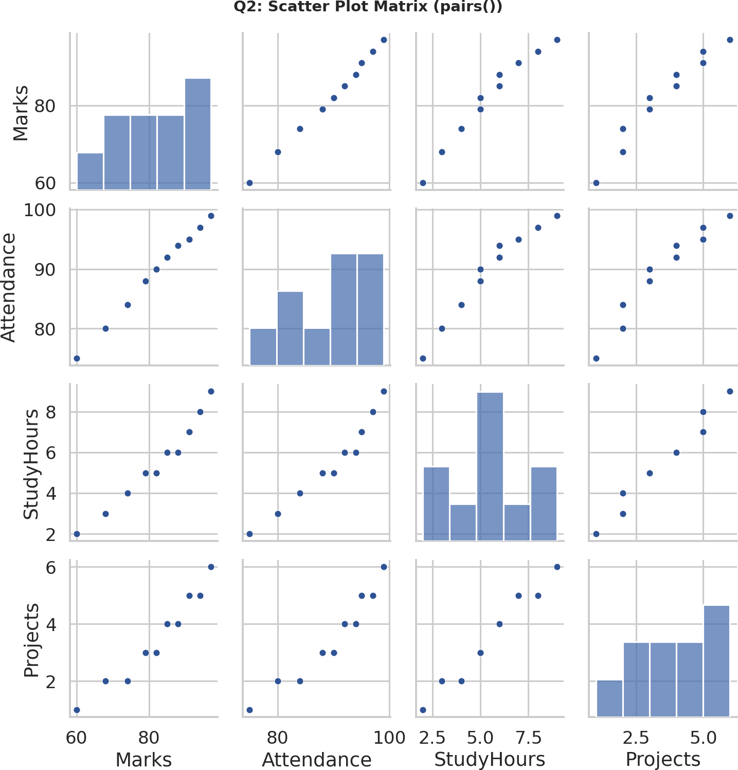
Figure 4.2 (Q2) - Scatter plot matrix (pairs()) of all four numeric variables.

Q3. Correlation among Marks, Attendance, and Study Hours.
cor() gives: Marks-Attendance = 0.998, Marks-StudyHours = 0.981, Attendance-StudyHours = 0.974 - all extremely strong positive correlations, meaning students who study more also attend more and score higher, essentially in lock-step.
Q4. Student with highest marks and largest bubble.
Student J - 97 marks (highest) and 9 study hours (also the largest bubble in Figure 4.1), confirming that the top scorer is also the one who studied the most.
Q5. Heatmap of relationships among all numerical variables.
See Figure 4.3 below - correlation heatmap across Marks, Attendance, Study Hours, and Projects.
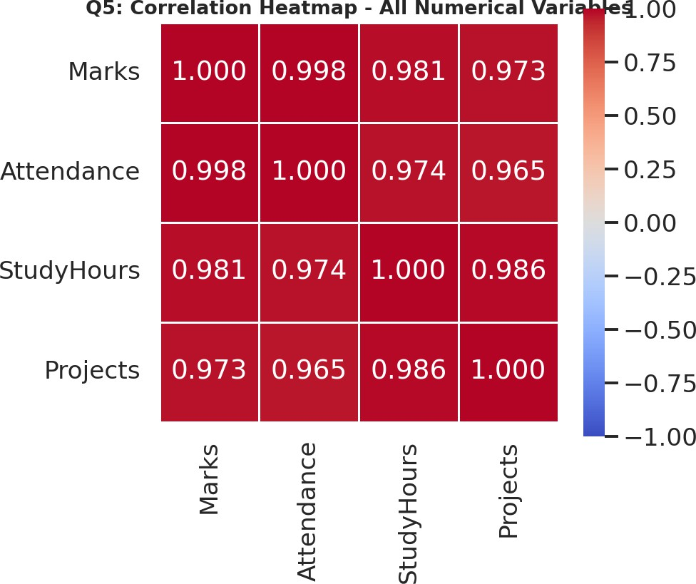

Figure 4.3 (Q5) - Correlation heatmap of all numeric variables (all pairs strongly positive, r > 0.96).

Activity 5: Integrated Data Visualization Exercise
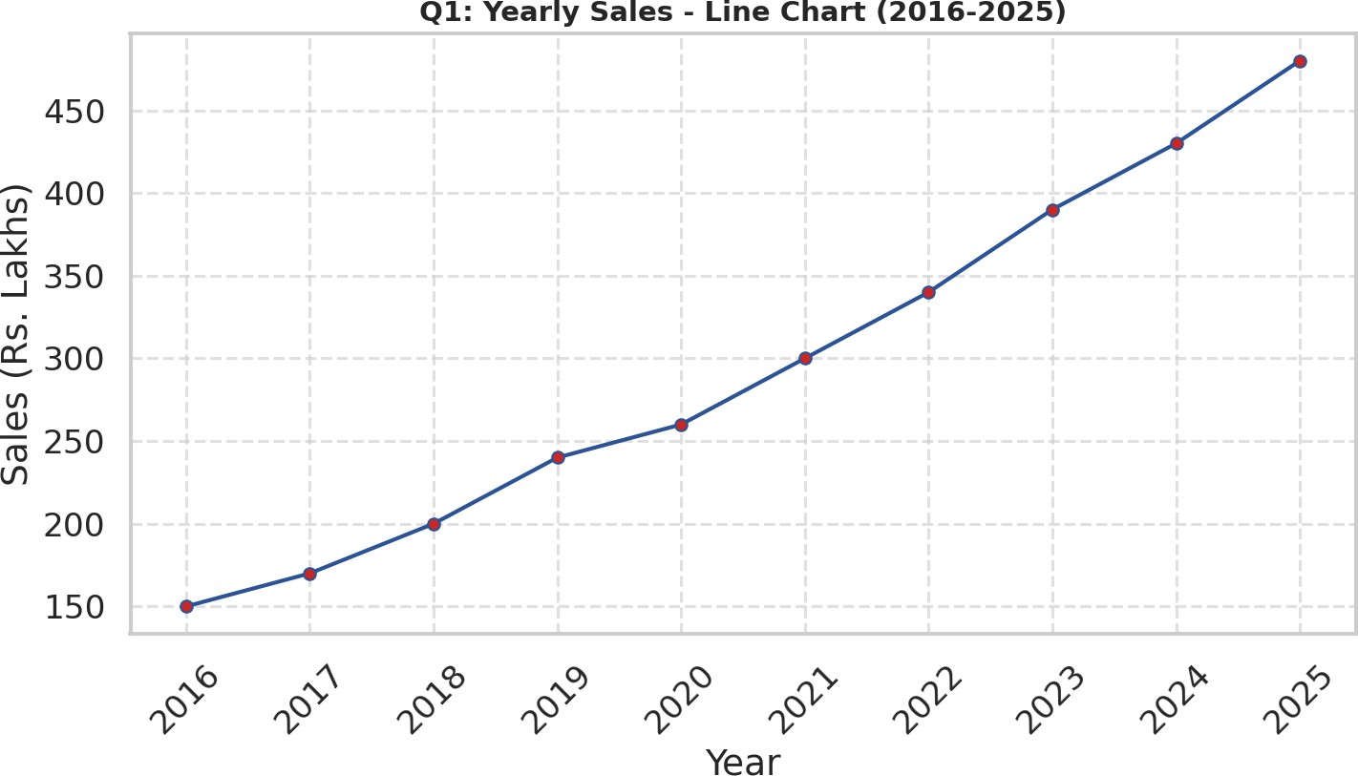

Figure 5.1 (Q1) - Yearly sales line chart, 2016-2025.

Q1. Temporal line chart of yearly sales.
See Figure 5.1 - sales grow every year without exception, from Rs. 150 Lakhs (2016) to Rs. 480 Lakhs (2025), a 3.2x increase over the decade.
Q2. Multivariate bubble plot - Sales (x), Profit (y), size = Customers.
See Figure 5.2 below - bubble size scales with the Customers column, color encodes Year.
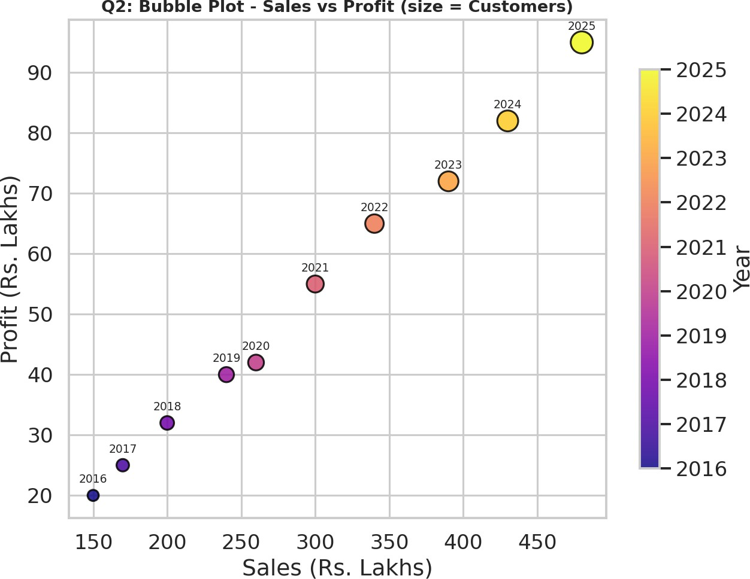
Figure 5.2 (Q2) - Bubble plot: Sales vs Profit, bubble size = Customers, colored by year.

Q3. Correlation matrix for Sales, Profit, Customers, and Branches.
cor() on all four variables gives: Sales-Customers = 0.9996, Sales-Profit = 0.9982, Profit-Branches = 0.9986, Customers-Branches = 0.9959, Sales-Branches = 0.9957, Profit-Customers = 0.9981 - every pair is almost perfectly positively correlated, showing the company has scaled sales, profit, customer base, and branch count together in a highly consistent growth pattern.

Q4. Scatter plot matrix using pairs().
See Figure 5.3 below - every pairwise relationship shows a clean, near-linear upward trend, consistent with the near-1.0 correlations above.
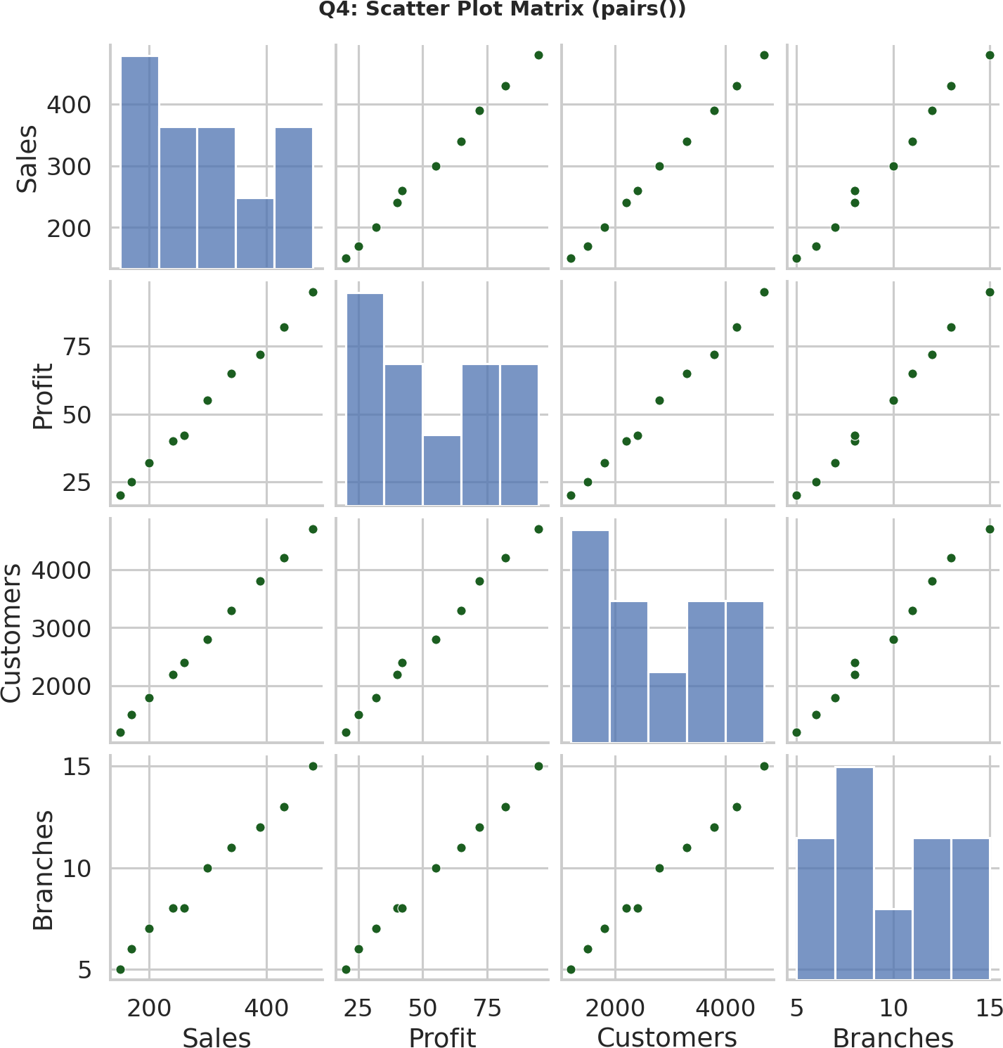
Figure 5.3 (Q4) - Scatter plot matrix (pairs()) of Sales, Profit, Customers, and Branches.

